**Programming and Application**

**By Devi Sri Charan**

Using Git 2

Link to the remote Git repository hosting the project 3

Commit History 3

Branch Management and Merging Processes 3

Tagging and Release 5

# Using Git

## Link to the remote Git repository hosting the project

<https://github.com/devisri-charan/bootcamp>

## Commit History

Below is the log of commit history with clear and descriptive messages

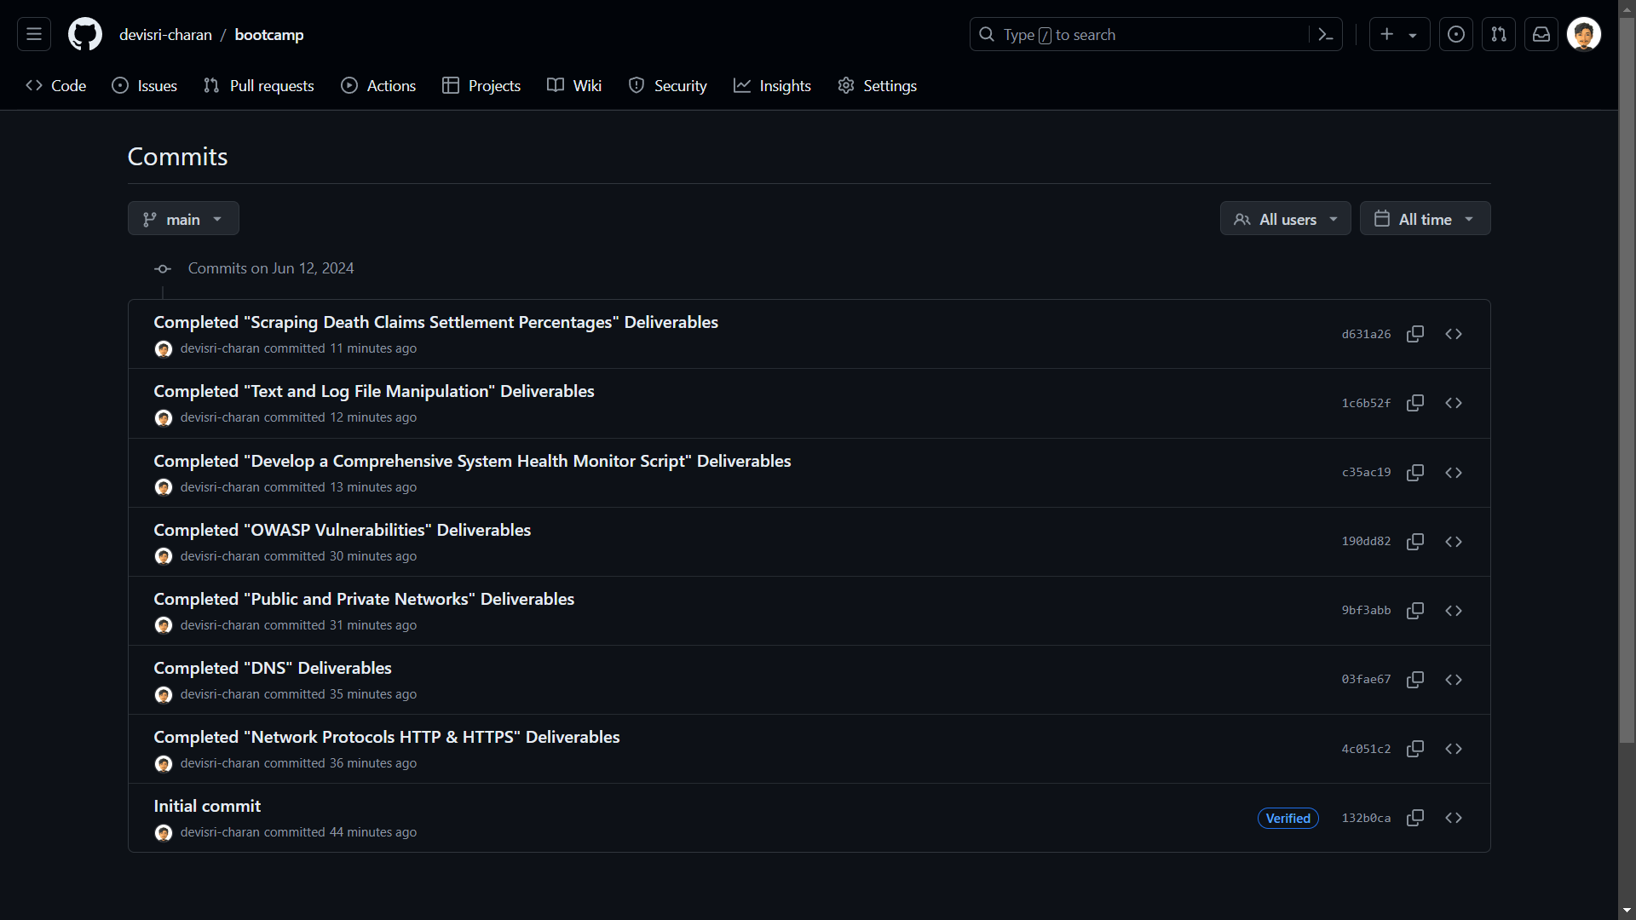

## Branch Management and Merging Processes

I have created one more branch (`origin`) other than `main` branch. Then I opened a pull request to merge the two branches. Since there are no conflicts. I have merged the two branches.

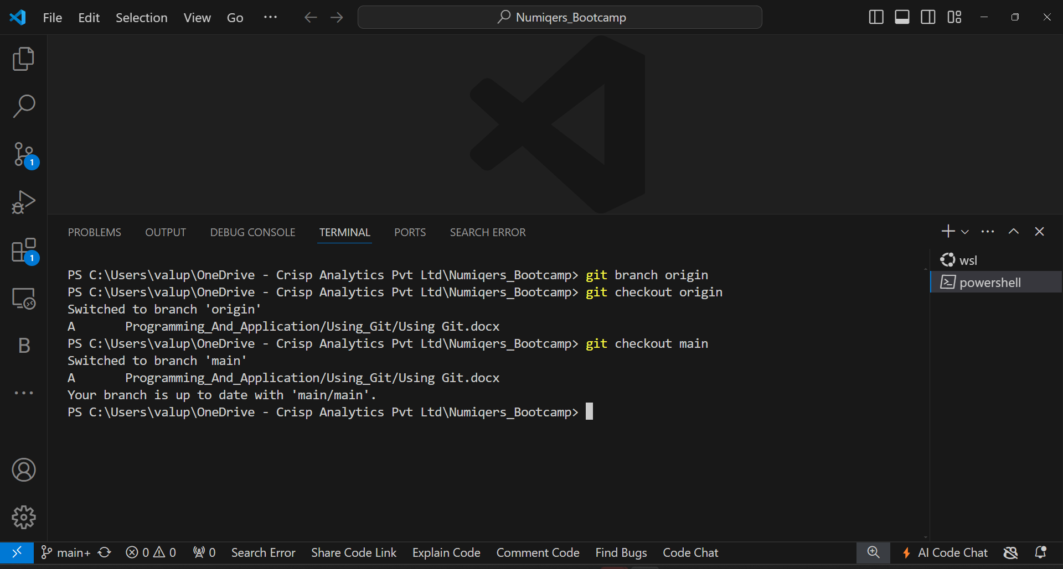

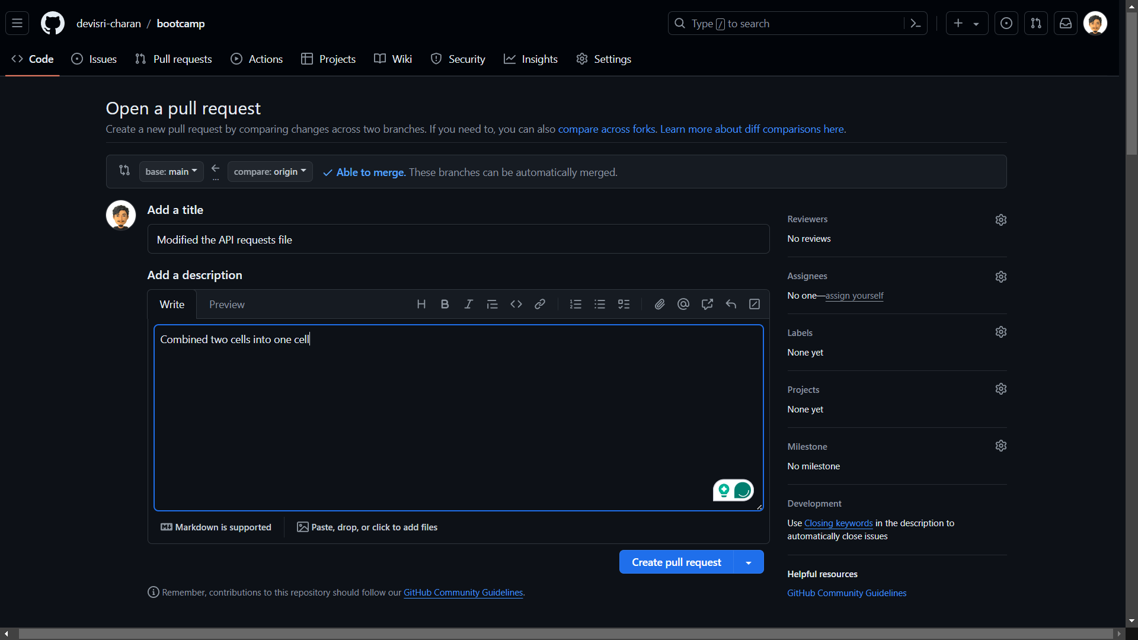

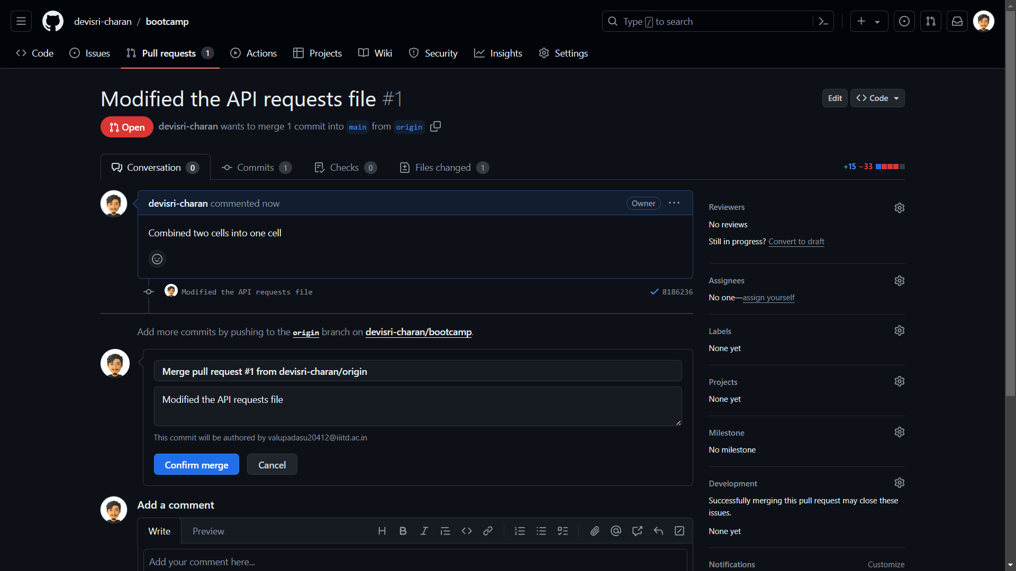

## Tagging and Release

I have created a tag `v1.0.0` indicating version 1.0.0. I have created a release named “Version 1” with all the commits with the above tag

